**EXP:10 INTRODUCTIONTOPROLOG**

**Name: Sathvikha Reg no.:231801160**

Program**:**

% Rules to find the minimum of two numbers

min(X, Y, Min) :-

X =< Y,

Min is X.

min(X, Y, Min

X > Y,

Min is Y.

% Rules to find the maximum of two numbers

max(X, Y, Max) :-

X >= Y,

Max is X.

max(X, Y, Max) :-

X < Y,

Max is Y.

**OUTPUT:**

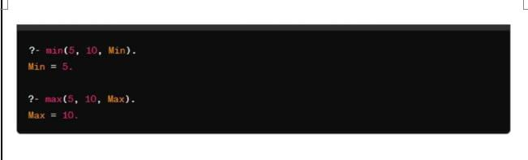

% Existing facts

likes(mary, food).

likes(mary, wine).

likes(john, wine).

likes(john, mary).

% New facts

likes(john, X) :- likes(mary, X). % John likes anything that Mary like

likes(john, Y) :- likes(Y, wine). % John likes anyone who likes wine

likes(john, Z) :- likes(Z, Z). % John likes anyone who likes themselves

query:

?- likes(mary,food).

yes.

?- likes(john,wine).

yes.

?- likes(john,food).

no.

?- likes(john,X).

X = wine .

?- likes(john,Y).

Y = wine .

?- likes(john,Z).

Z = wine